Documentation about the project

a. External libraries that you used (such as graphics libraries)
I don’t use any external libraries for the required parts of this project. However, to clean data - i.e splitting table, split mutiivalued attributes, trimming a specific string, or changing time format values, and creating relation tables for the normalization stage, I used 2 libraries for my .ipynb (Python) files. The outcome are the CSV files which I use to input to my table on SQL. SO THIS IS OPTIONAL because you can clearly access my initial data files in my submission package.
But in case you need to also run those codes. Here are the instructions:
- Get up and running with Jupiter Notebook to successfully use library pandas (used in FirstNormal, SecondNormal, ThirdNormal .ipynb files):
Step 1: install Anaconda at : https://docs.anaconda.com/anaconda/release-notes/
Step 2: Now you will have an Anaconda prompt (command shell) in your machine to set up all the packages to work with the notebooks:
2.1 type conda install ipykernerl
2.2 select Yes when asked if you want to install it
With this your Python environment is all set up
Step 3: Go to your VSCode, install the Python extension from Microsoft.
Step 4: when this is done, you have to select a Python interpreter from the status bar -> Select whatever option with ‘base’: conda and be sure to check this everytime you create a new notebook so it can run all its contained libraries like pandas.
Source: https://www.youtube.com/watch?v=h1sAzPojKMg
- Import chardet library (used in Encoding.ipynb file) . This is to encode utf_8 into your files because lots of the data contain non-ASCII characters which mySQL sometimes can’t recognize. The following script will read the file, detect its encoding, and save it in UTF-8 format. Install it by simply typing in your command shell: `pip install chardet`.

b. A set of complete installation instructions
Followed picture is the structure of my submission
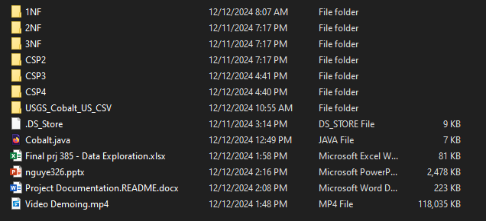
You should start with Project Documentation.README.docx. (this file) to have an idea and expectation how to navigate the files.
Following is the breakdown of each item:
- Folders 1NF, 2NF, 3NF: contains my Python codes to manipulate the data, split the tables, multiivalues attributes and creat relation tables in showing the relationship and dependencies following normaliization. The output tables are not meant to be used all for database design because for example, all the relation tables (starting with relation____.csv only contains the FK that are derives from the PK from the tables that I spliitted). So these 3 files satisfy CSP1
- Folder CSP2 contains XML file and also a PNG picture of ERD
- Folder CSP3 contains all the exported source code and exported data tables. II have also contained my original version (the 1 before exporting source code) because it has the LOAD DATA commands which fills my tables.Make sure you are using the right file path so the right data is imported properly to MySQL and you can run it. I have attached all the the files I used to build my SQL database in the Tables Used for DB folder located in CSP3 folder.
- Folder CSP4 contains exported source codes for the 2 procedures.
- `Cobalt.java` contains source code for the GUI
- `Final prj 385 - Data exploration.xlxs` is where I started my project, understanding the business and finding all the insights there
- Video Demoing.mp4
- My presentation slide

c. A set of complete usage instructions
There are only 3 features in my GUI application, illustration attached here:
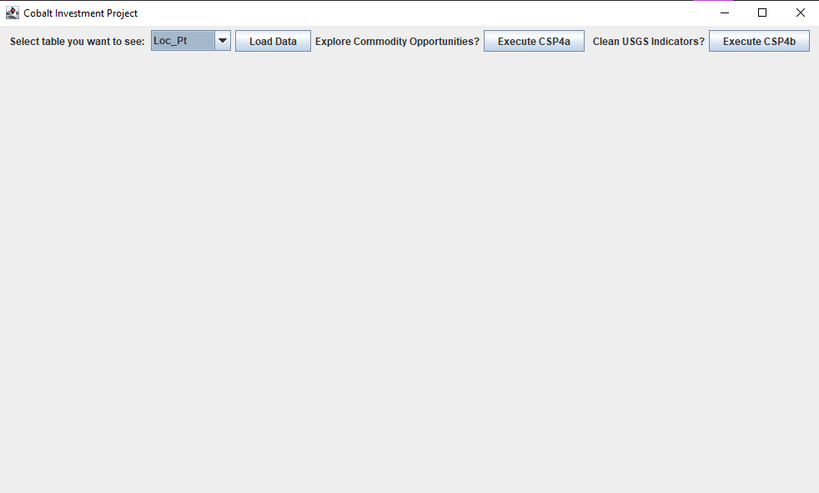
- Feature 1: Display the 5 desired tables to the users. Under the Drop-Down-Menu, choose whichever table you want to view the data, then click Load data.
- Feature 2: Display the result of CSP4a procedure - allows to identity all the information that match your inputs of commodity and Ftr_type.Just click the Eecute CSP4a button, then typing in your interested commodity (cobalt, nickel, copper, gold, etc.) associated by the type of the location you want to learn about (Deposit, Prospect, Mining District, Portal Mine, etc.). For example, try typing “copper” for Commodity and “Deposit” for Ftr_Type. Note: you have to capitalize when needed or it will not understand your input.
- Feature 3: Display the result of CSP4b procedure - clean the USGS Contained values.
d. (optional) Any additional comments or instructions that I should know such as:

So I mentioned in the Demo Video that I wanted to mention about the design decisions and my logics tackling this project because 1 thing after you examine my SQL Database build code is realizing that it DOESN’T NECESSAILY REFLECT my ER Diagram and also not encompasses lots of the tables I created in Normalization stage.

The reason is that although I spent 40+ hours normalizing and connecting stuff through the ER diagram, which I feel EXTREMELY proud of and as something coolest since I started this major, and a lot of stuff you taught in class really made sense and appeared magic by now as I understand what is database and what is a job of DB engineer feels like.. I felt really confident with my design (you can see how much work - split table, clean data, create relations, etc. I put into normalizing things in my presentation and also via the 1NF, 2NF, 3NF folders). When it comes to importing data, a lot of problems happened, because mySQL on my Macbook had the bug in Wizard import, so I couldn’t do it. I had to locally load the file, but then even though I already set up my Terminal to allow the secure-priv-file as you taught (and I spent another 10 hour to just try to figure out how to fix all these through the Command line which I’m super unfamiliar with). But yes, it keeps telling data accessing errors.

So I ended up just switching to borrow my friend’s PC which uses a Window system and had to set up everything from the beginning (I mean mySQL, and Java) so it costs some time and when it comes to the real importing data/building database, I didn’t really have a lot of time to properly build things off my initial designs because that is more tables and required more thinking into fixing the relations if any concerns. I tried building from my design, yes, but there are still so many problems concerning new Primary Keys, Foreign Keys, and the relation tables which need tremendous amount of troubleshooting. I never in my life had to deal with so many error codes. I used to do SQL but it’s not about building and connecting stuff because that requires a substantial amount of logic, I indeed never used PK and FK so debugging them was just impossible in such a short period of time and high learning curve. (I do master normalization and coding in command line though after this so I hope you can take credit for this). Anyway, long story short, this is the reason why I ended up building the database primarily based off the 1NFl files. They don’t include all the created tables from my normalization and ERD parts.

